BSI.IT.10.C11 – Vendor Defaults – CDA (2026)
IT RCSA – Configuration Management
Item | Detail
Control | BSI.IT.10.C11 – Vendor Defaults (Heracles 50539549)
Risk | [BSI.IT.10.R3 PW Config] Unauthorized access to systems and data due to failure to enforce strong password configurations may result in data compromise, system and business disruptions, financial loss, and regulatory noncompliance. (High)
Owner / executor | Ian Rojo
Relevance / nature / frequency | Key Control / Hybrid / In every operation
Testing period | 07/01/2025 – 06/30/2026
Prepared by / reviewer | Edward Morfa (IT RCSA) / Amanda Munoz Henry (Testing Manager)
Evidence | Folder BSI.IT.10.C11 Vendor Defaults/Evidence – files start with their E-number. Screenshots in Evidence/Screenshots.

Control statement
[BSI.IT.10.C11 Vendor Defaults] In every operation, Infrastructure teams change vendor default passwords for root or administrator accounts on Operating Systems before the server reaches install status in CMDB.
How to read this: each question has the answer first, then the reason, then where to look. 'E04d line 15' means evidence file E04d, line 15. 'E01 p.12' means page 12 of E01.
Evidence used
Ref | What it is
E01 | Secure Build and Configuration Management Standard v6.0, approved 05/28/2024 – SUS.SBS.4.2.3.4 on p.12
E01a | Same Standard v8.0, approved 07/28/2026 (after the period) – SUS.SBS.4.2.3.4 on p.11, same wording
E02 | Windows Server Hardening Guide – rename built-in Administrator (p.14)
E03 | Linux Red Hat Hardening Guide v3.0 (01/05/2026) – root password set, Local Ref 100 (p.18); PermitRootLogin out of scope, Ref 81 (p.31)
E04a-e | Windows security exports (secedit) for MIA-DC-SPFAM1, SPFAM2, SQLPECS, SQLPRD01, SPOINTIQ
E05 | Linux screenshots 10/30/2026 – PermitRootLogin for mia-dc-analytics, miadcpositconn01, miadcpositdata, miadcpositwork02, ashbastion
E06 | SEF exceptions approved 07/01/2025 – 07/04/2026 – the file is empty
E07 | Coverage period calculation
E08 | WP2 C11 2025 (prior year)
E09 | CMDB extract 11/04/2026 (5 rows, all created April 2025 – not a population)
E10 | CMDB 2025 new servers list (prior year C19 file) – shows status in mid-2025

In the folder but not used for this control:
- BSI.IT.10.C11.03 Oracle Hardening Guide.pdf – Databases moved to BSI.IT.10.C10 in the 2026 control statement
- BSI.IT.10.C11.04 Microsoft SQL Server Hardening Guide.pdf – Same – database, now C10
- BSI.IT.10.C11.08 SQL hardening evidence.docx – Same – database, now C10
- BSI.IT.10.C11.09 SQL servers.xlsx – Same file as 2025 (Qualys scan 05/04/2025) and database scope
- C13 Linux-evidenceNov2026.docx – Belongs to C13 – filed there as E05
Testing period
Annual test. The 2025 test covered 10/01/2024 – 06/30/2025, so this one starts 07/01/2025 (RCSA Testing Procedure 4.4.2; E07). C11 was rated effective three times in a row (2026 Test Plan, tab 24 Mos). GRC also shows an assessment on 12/22/2025 – if that Cycle 2 population ran past 06/30/2025, move the start date (E07 note).
Design questions
1. Is the control designed with an appropriate frequency or trigger?
Yes. The trigger is every server build. The default password for the built-in Administrator (Windows) or root (Linux) has to be changed during the build, before the server moves to Installed in CMDB. That is the right point: once a server is Installed it is live, so a default password after that point is open to anyone who knows it. Windows builds get the domain policy that renames Administrator to BSITADM and renames and disables Guest (E04, lines 15-20). On Linux the root password is set by the admin during the install; RHEL does not ship with a default root password.
Reference: E04a-e lines 15-20; E03 p.18 (Ref 100); 2025 walkthrough in E08 (CDA Q1)
2. Is there a defined audit trail/evidence which supports the execution of the control being performed?
Yes. Partly. The current configuration can be shown: secedit exports for Windows and command output for Linux, plus the CMDB record with its status history. What is missing is a record of the password change itself and its date. A renamed Administrator is not a changed password, and PermitRootLogin only stops root logging in over SSH. To prove the control as written, the team needs something like the LAPS / CyberArk record or the password-last-set date for BSITADM, and 'chage -l root' (last password change) for Linux, compared to the CMDB install date. Observation – it does not stop the control from working.
Reference: E04a-e; E05; E09
3. Is the control aligned with internal policies and/or applicable regulations?
Yes. SUS.SBS.4.2.3.4 says secure configurations must remove, change or disable all default accounts and change default passwords for accounts that cannot be removed or disabled (E01 p.12; same in E01a p.11). The Windows guide asks to rename the built-in Administrator (E02 p.14). The Linux guide asks for a root password set with SHA512 (E03 p.18, Ref 100). Observation: the Linux evidence we got checks PermitRootLogin, and that rule was moved out of scope in the Linux guide because hardening sshd broke MoveIT FTP jobs (E03 p.31, Ref 81). So it is not the right test for this control.
Reference: E01 p.12; E01a p.11; E02 p.14; E03 p.18, p.31
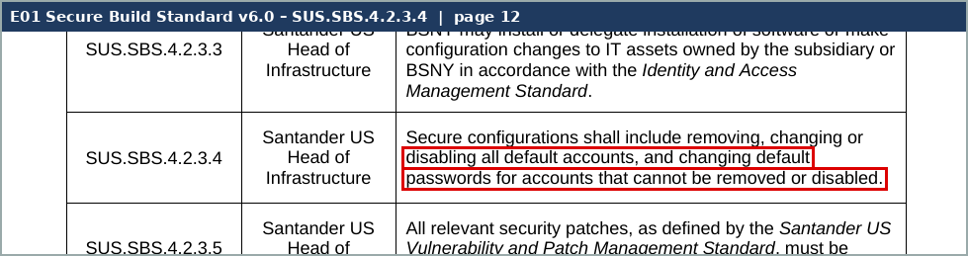
Screenshot 1 – C11_S4_SBS_4.2.3.4.png (Evidence/Screenshots)
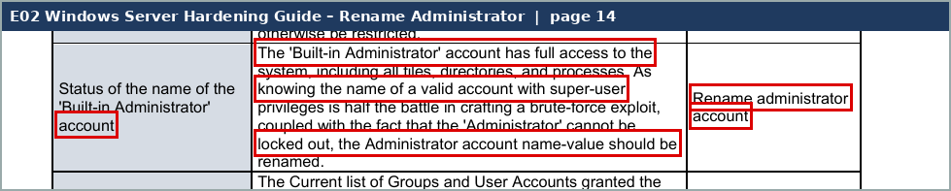
Screenshot 2 – C11_S5_Win_rename_admin.png (Evidence/Screenshots)
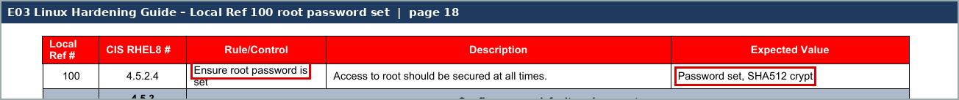
Screenshot 3 – C11_S6_Linux_root_password.png (Evidence/Screenshots)
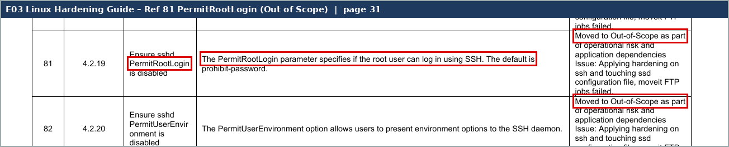
Screenshot 4 – C11_S7_Linux_PermitRootLogin_OOS.png (Evidence/Screenshots)
4. Are the thresholds for execution/resolution appropriate?
N/A. Not required – Key control. The template asks this only for SMC Group / SMC Local.
5. To what level is the issue escalation process defined and implemented?
Full. Same as 2025. InfoSec scans flag vendor defaults and send them to Infrastructure in the weekly / monthly meetings. A default that cannot be changed goes to the SEF meeting for CISO approval. No exceptions were approved for these servers in the period – the SEF list is empty (E06).
Reference: E08 CDA Q5; E06
6. How reliable is the information which the control is dependent upon?
Moderately Reliable. The exports are system-generated, but three of the five Windows files have no server name inside, so only the file name ties them to a server. MIA-DC-SPFAM1 and MIA-DC-SPFAM2 are the same file, byte for byte (same MD5). The CMDB extract we got (E09) has 5 rows from April 2025, so it cannot be used as the population. The Windows build is automated; Linux builds are manual.
Reference: E04a-e (MD5 in screenshot C11_S2); E09
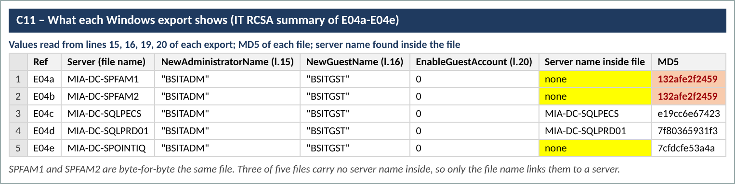
Screenshot 5 – C11_S2_export_summary.png (Evidence/Screenshots)
7. Is the process to obtain evidence of the control execution simple?
Yes. Exports and command output take minutes. The CMDB install dates and the password-change dates are a separate request but come from the same teams.
Reference: E04a-e; E05
Walkthrough and sample of one
Walkthrough: [date and attendees to be confirmed – in 2025 the walkthrough was 05/01/2025 with Cesar Vidal, Cesar Rubio, Evelio Heredia and Jossett Morales]. Ask the control owner, Ian Rojo, to confirm the process did not change and to walk us through one build end to end.
How it works. A new server is requested and built by Infrastructure. Windows servers come from the standard image and join the domain, where the security policy renames the built-in Administrator to BSITADM, renames Guest to BSITGST and keeps Guest disabled. The local Administrator password is set during the build. Linux (RHEL) servers are built by hand and the admin sets the root password during the install. When the build is done the CI status in CMDB moves to Installed. That move is the deadline in the control statement.
What changed in 2026. The control statement now covers only root and administrator accounts on operating systems. Database defaults (Oracle, SQL) moved to BSI.IT.10.C10, so the SQL and Oracle files in the evidence folder were not used for C11.
Sample of one – MIA-DC-SQLPRD01 (Windows)
What we checked | What we saw | Where | Result
Server in scope | Listed in the 2025 CMDB as created 05/14/2025 and 'Pending Install' (E10 row 25), so it should have reached Installed during this period | E10 row 25 | Observation – install date needed
Export belongs to the server | File carries the server name inside (SQL service accounts ...$MIA-DC-SQLPRD01) | E04d | Pass
Built-in Administrator renamed | NewAdministratorName = "BSITADM" | E04d line 15 | Pass
Guest renamed and disabled | NewGuestName = "BSITGST"; EnableGuestAccount = 0 | E04d lines 16, 20 | Pass
Default password changed | Not shown – secedit does not hold passwords or the password-last-set date | – | Not evidenced
Done before CMDB Installed | No install date provided | E09 (no row) | Not evidenced

The rename part of the build worked on this server. We cannot yet say the password was changed before the server went to Installed. That is the gap we will close in the CPA with the open items below.
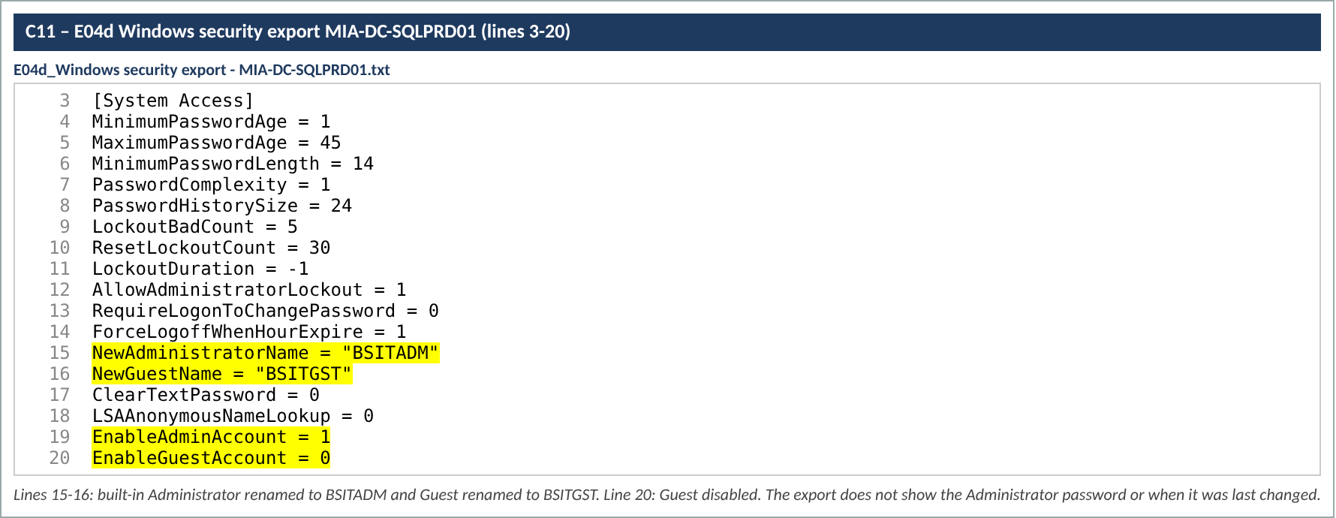
Screenshot 6 – C11_S1_SQLPRD01_export.png (Evidence/Screenshots)
Design observations
- (1) No record of the password change or its date. The evidence shows renamed / disabled accounts, not changed passwords.
- (2) The Linux check used (PermitRootLogin) is out of scope in the Linux guide; the in-scope rule is Ref 100 (root password set).
- (3) Three Windows exports have no server name inside and two are identical files.
- (4) The control statement changed; databases are now in C10. The SQL list in the folder is the 2025 file (scan 05/04/2025).
Calculated rating: Satisfactory
The design is fine for the risk: the password change sits inside the build, before the server goes live, and it matches SUS.SBS.4.2.3.4 and both hardening guides. The weak point is the evidence trail – nothing records the password change and its date, so the team shows configuration instead. Hybrid control, so the rating cannot go above Satisfactory (Testing Procedure 4.3.5).

